

**MacOS Theming Temple <= This will be substituted by the company name and logo!**

**Glow**

The best theming tool for macOS

Glow makes macOS flexible again by injecting your predefined and preferred elements into the system. It’s easy to use and professionally developed to make theming fun again. Glow will take care of the most important system elements such as scroll bars, “traffic lights”, title bars, (pop-up) windows, pull-down menus and (segmented) buttons. It’s also possible to define states for certain elements, change the Dock appearance and import icon sets.

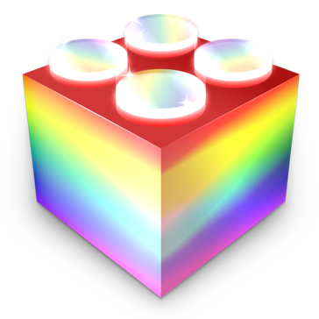

REMARKS:

This document and its components will be ported to different entities and more appropriate tools once we agree on its content.

These draft instructions focus primarily on the ARM-platform and the most recent operating systems.

Instructions for Intel and older operating systems - where applicable - will be added afterwards.

The difference between Retina and non-Retina elements are indicated by the presence of the famous “@2x”-indication at the end of the element name for Retina (see the overview of elements below). As a rule of thumb, you can create a non-Retina element from a Retina element by dividing the dimensions by two and omitting the string "@2x"; vice versa.

**Instructions**

**Preparation**

Backup your current system.

It is necessary to disable both System Integrity Protection (SIP) and Library Validation (but you don’t have to disable authenticated-root).

For Silicon based systems: Restart with *macOS Recovery System* (by holding the *Touch ID* button during startup until “Continue holding for startup options…” appears).

After a while, choose “Options…”, click “Continue”, select your admin user, click “Next” and confirm with the corresponding password.

For Intel based systems: Restart with *macOS Recovery System* (by holding down [Command] + [R].

For all systems: Select (from the menu bar) *Utilities > Terminal* and enter the command: “**csrutil disable**” in order to disable SIP.

Restart your computer for the changes to take effect and to exit *macOS Recovery System*.

Users of Silicon based computers also need to enable the arm64e preview ABI by typing the following command or copying the next string into *Terminal*: “**sudo nvram boot-args=-arm64e_preview_abi**”.

**Installing Ammonia**

Because Glow actually tweaks the system, you need to install a so-called tweak manager to enable this. In this case you have to install Ammonia first using the dedicated installer, which you can download here [not active yet].

**Installing Glow**

Glow tweaks a set of elements, which are basically part of macOS. You can download the Installer for Glow (glow.pkg) when you click on this link [for the time being]: https://drive.google.com/file/d/13niSI90ezw4COuoovnIJuwv0Vk1_rLmB/view.

Double-click on the downloaded Installer and follow the designated steps.

Finally restart your system again.

**Checking installation**

Before you start to use Glow, it is advisable to check whether all necessary settings and components have been installed correctly.

Within /private/var you should see a folder with the name “ammonia”.

If that is not present, try to redo all steps indicated above.

**Creating your own theme**

If Glow is running smoothly on your system, you can create your own theme.

In that case, you have to follow the specifications as stated in the next overview [under construction]:

The basic set is shown below as an example. The extended set is attached as Enclosure 2.



ATTENTION: Most elements have rather long names. (This naming convention is actually defined by Apple. It’s best to modify existing elements or to copy these names from one of the overviews.

Finally, you need to specify certain variables in the Property List “settings.plist”, which resides in the theme folder. You can customize these entries according to your needs.

**NAME TYPE EXPLANATION**

gHideDecora boolean hide title bar highlight

gMicaTile dictionary tile mica

gMicaSlices dictionary mica slices

gColors dictionary color entries

gControlSpacing number traffic light spacing

gHideWindowRim boolean self-explanatory

gWindowShadowActiveRadius number self-explanatory gWindowShadowInactiveRadius number self-explanatory

gFontReplacements dictionary font overrides

gDockSlices dictionary Dock slices, similar to mica

gDockTouchesGround boolean touch the ground dock!

gDockBottom integer height from bottom of screen

gDockRight integer distance from right of screen

gDockLeft integer distance from left of screen

gPatchAppearance boolean patch nsappearance option

gMiniToolbar boolean small toolbars?

gTitlebarHeights integer title bar height

Greyed out entries are still buggy.

An example of a *settings.plist* will be included in the default basic theme.

Be aware that different states are possible with certain items, such as with some buttons and the WindowControlButtons (a.k.a. “traffic lights”). The following overviews apply to the latter. As you can see, in that case two digits are added to the end of the name: the first indicates the status and the second the intended action.

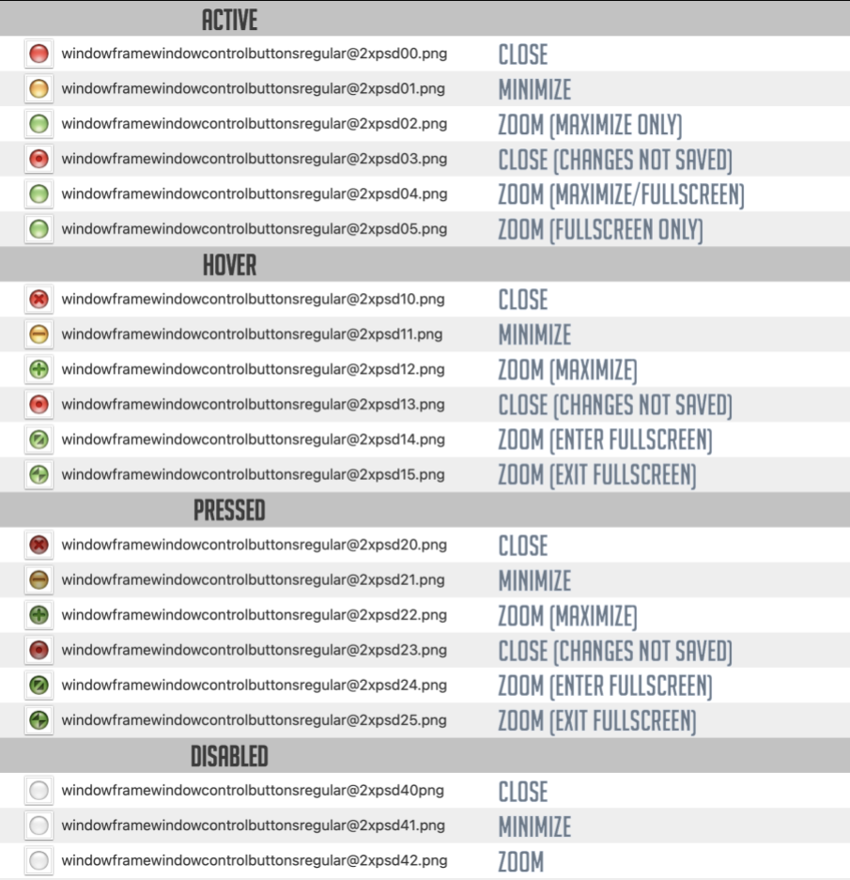

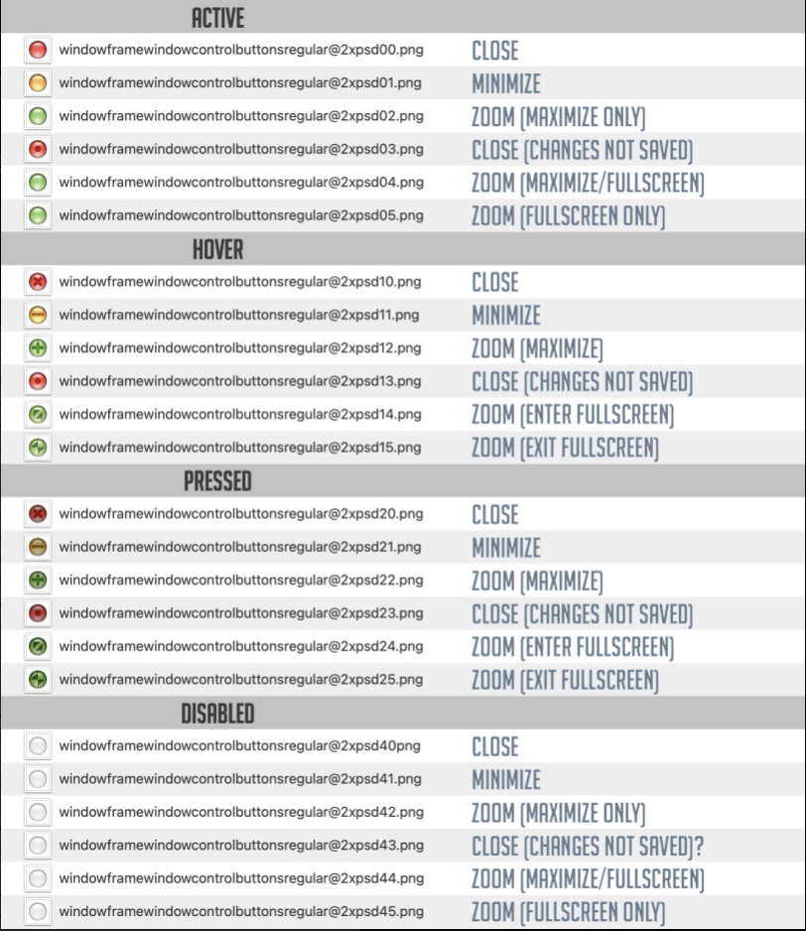

After updating your theme, you need to make sure that the folder with updated elements is stored at /Library/Glow.

**Changing Dock appearance**

You can create your own Dock and related icons.

The requirements are listed below:

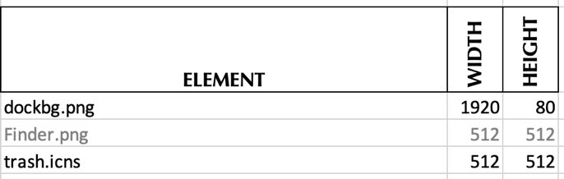

All other Dock icons are automatically loaded at start-up, as they are defined by the system, a special utility and/or by Glow (see next chapter).

**Importing icon sets**

With Glow you can import your own icon set(s). The following list [still under construction] is intended as an example, while it essentially contains system icons; but you are free to design your own set(s) as long as you meet the macOS standards:

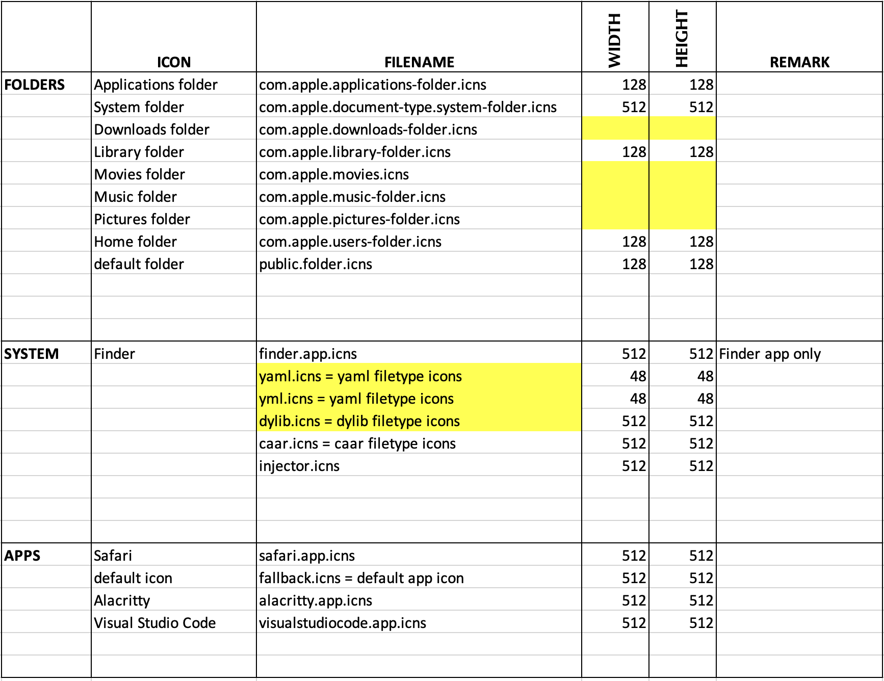

Although macOS supports icon sizes up to 2048*2048 pixels, 512*512 is rather common.

**Troubleshooting**

If you encounter a serious issue and/or the system freezes, you can always settle for just a logout via [Shift]+[Command]+{Option]+[Q].

If the problem persists, it is always possible to shut down your computer and enable SIP again and restart. Your Mac will automatically reset your system to the standard macOS.

It is always possible to delete /usr/local/bin/ammonia to restore your previous configuration and reboot.

[To be continued]

# **Enclosure 1: System Integrity Protection**

System Integrity Protection (SIP) is a macOS feature that is designed to help protect your Mac from malicious software by restricting the actions that the root user can perform on protected parts of the system.

Key Features of SIP:

• Prevents modification of system files and directories;

• Protects the system integrity of pre-installed apps like Finder, Safari and others;

• Restricts debugging and runtime modifications. (*This is the important one*.)

**Important**: Tools like Ammonia require SIP to be disabled to function.

**Important**: Disabling System Integrity Protection will also disable Apple Pay and prevent iOS apps downloaded from the App Store from running on your Mac.

**Disabling SIP**

• Restart with *macOS Recovery System* (by holding the *Touch ID* button during startup until “Continue holding for startup options…” appears).

• After a while choose “Options…”, click “Continue”, select your admin user, click “Next” and confirm with the corresponding password.

• Select *Utilities > Terminal* from the menu bar.

Enter: **csrutil disable**

*Reboot and wait for the system to be ready again.*

**Enabling SIP**

• Restart with *macOS Recovery System* (by holding the *Touch ID* button during startup until “Continue holding for startup options…” appears).

• After a while choose “Options…”, click “Continue”, select your admin user, click “Next” and confirm with the corresponding password.

• Select *Utilities > Terminal* from the menu bar.

Enter: **csrutil enable**

*Reboot and wait for the system to be ready again.*

# **Enclosure 2: Glow elements (expert level) [needs to be extended and improved]**

